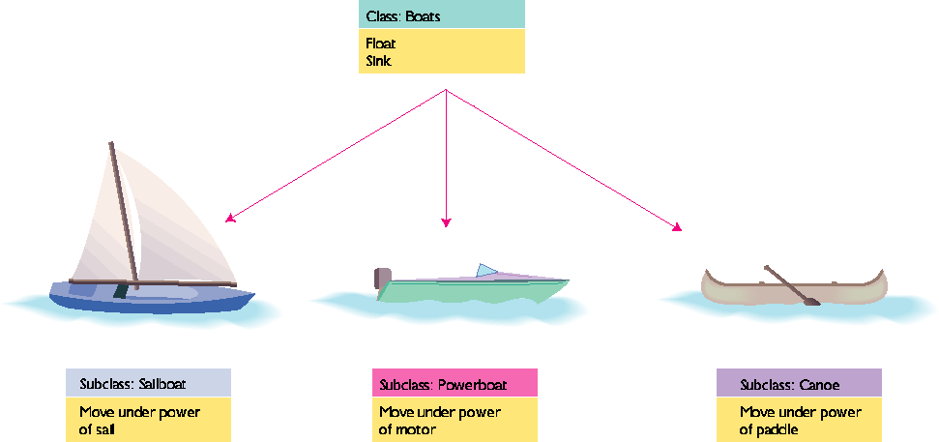
Inheritance in Object-Oriented Programming

